FIND :
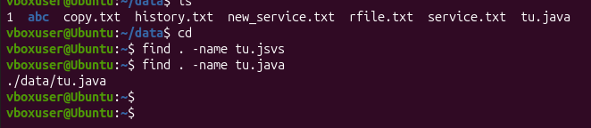
TO FIND THE FILE IN THE FILE MANAGER
CHANGE MODE :
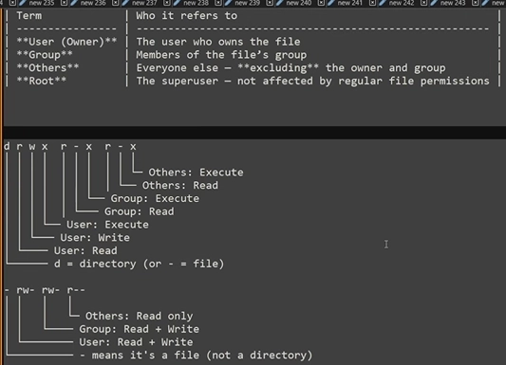
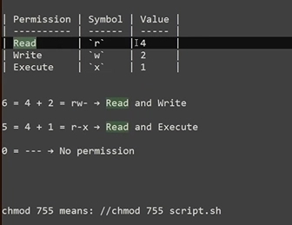
CHMOD AND LS -L TO VIEW PERMISSION :
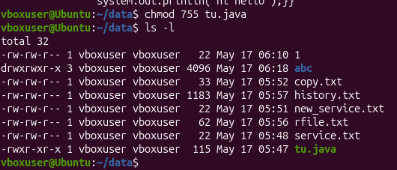

CHOWN :
sudo chown helpdeskuser file.txt:

TO ADD NEW USER :
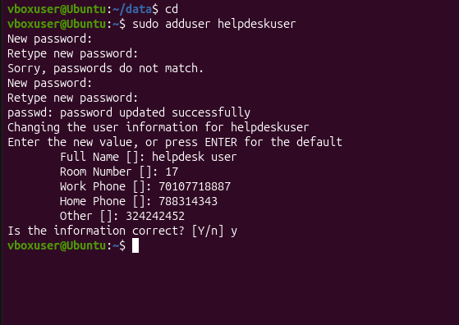

CHNGING THE PASSWORD :
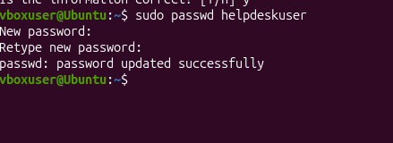

PASSWORD RESET :
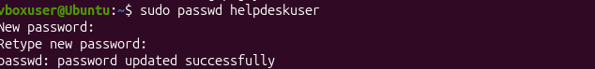

CREATING A GROUP AND ADDING MEMBERS TO THE GROUP :

GETTING ID OF THE USER :

